Maths.

Hello New Prospect Math’ mateers.
The Maths Department is really excited to be working with you this coming September. So in the mean time have a go at these.
Mixed Operations Riddle.
A  40/8 | B  23+18 | C  3x12 | D  5x12 | E  87-14 | F  16/4 | G  5x9 | H  8x6 | I  32-15
J  7x8 | K  41-13 | L  4x7 | M  22/11 | N  36+25 | O  50-13 | P  48/4 | Q  32/4 | R  22+58
S  2x9 | T  42/6 | U  45/5 | V  32-16 | X  36-15 | Y  7x9 | Z  12x6

All you have to do is answer the questions above and then solve the riddle below by using their answers.
Are Monsters good at Maths ?

61 | 37 | 7 |  | 9 | 61 | 28 | 73 | 18 | 18

63 | 77 | 9 |  | 36 | 37 | 9 | 61 | 7
 |  |  |  |  |  |  |  |  | End

Place Value.
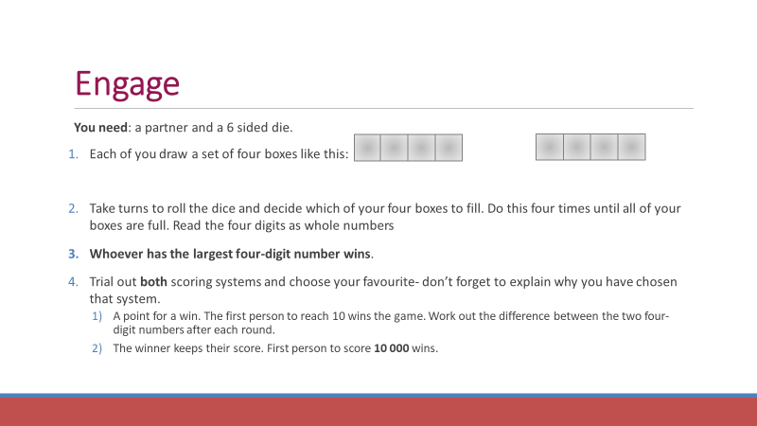
Consecutive Numbers
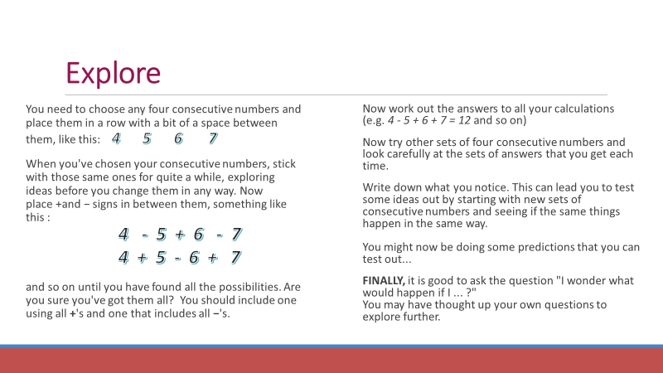
Consecutive numbers are numbers that follow each other like 1, 2, 3 , 4, or -4 , -3, -2 , -1 , 0
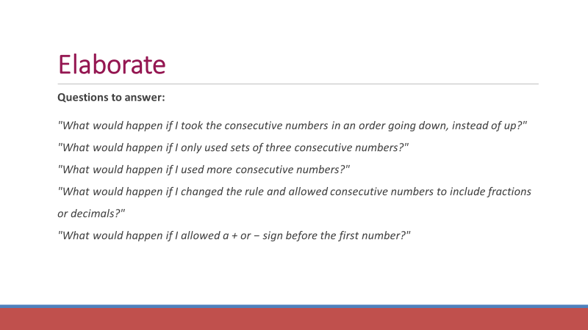
Negative Numbers.
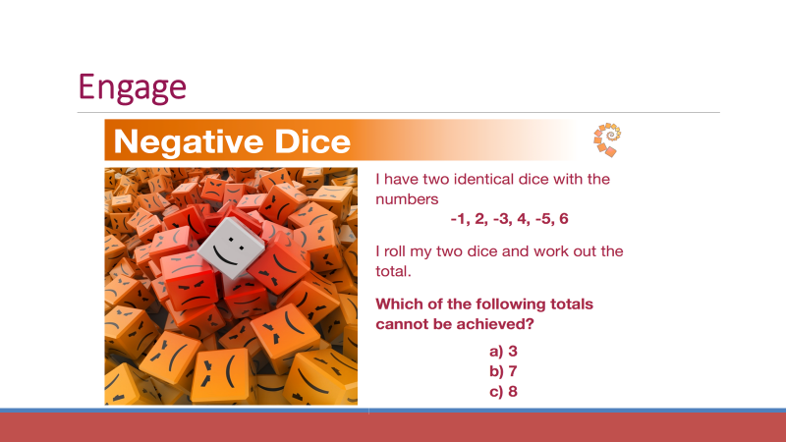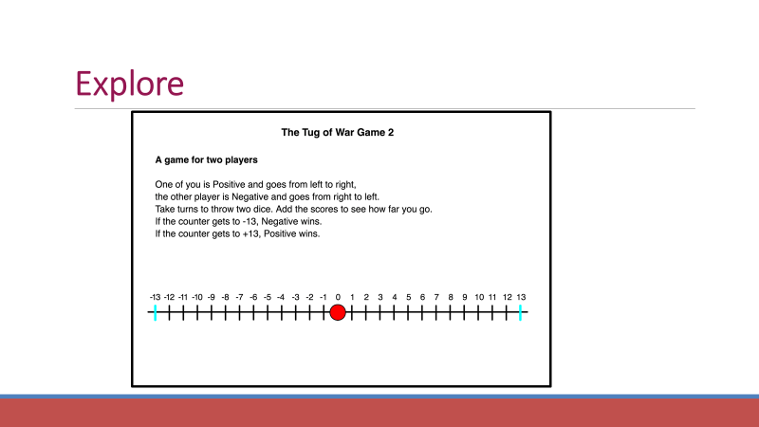

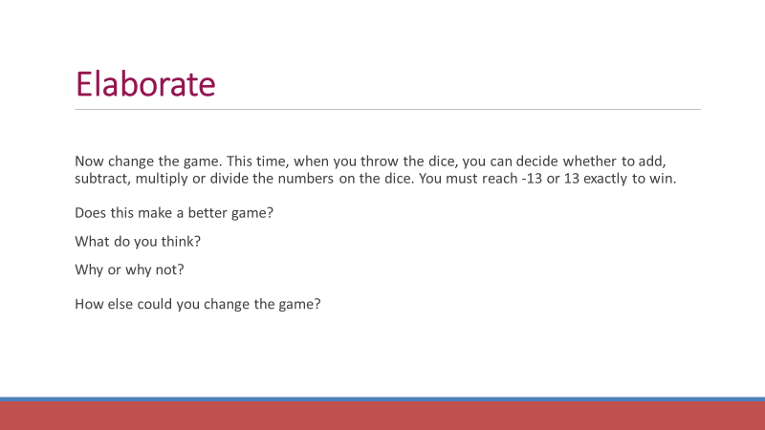

Add and Subtract.
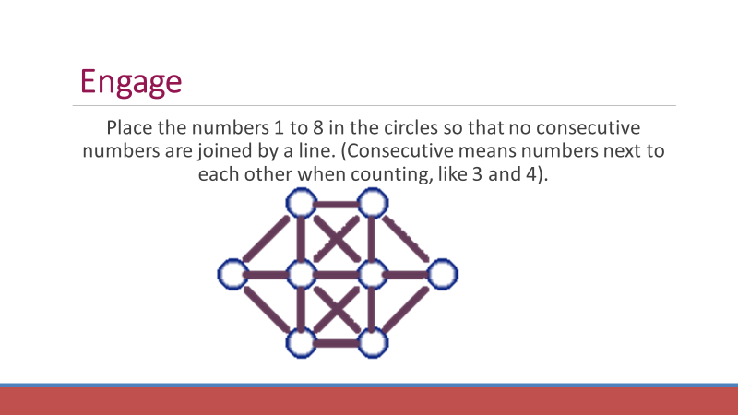
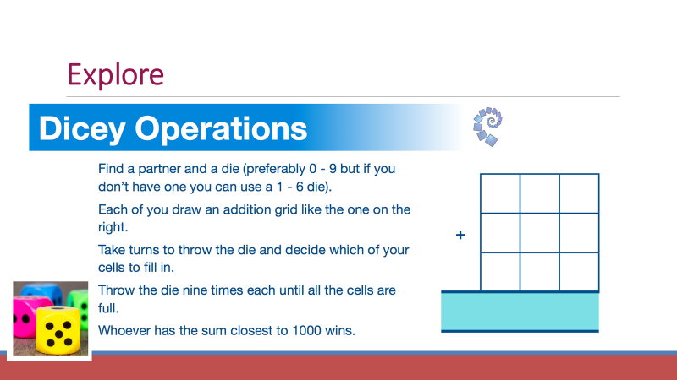
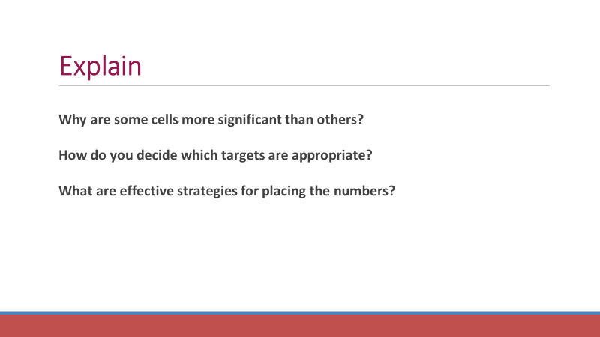

Now complete the code on the next page and then work out the message.
Then email pvacyash@prospect.reading.sch.uk when you are finished !

