Prospect’s English Department
Greek Mythology at Prospect School

Hello and welcome to the English Department here at Prospect. Please make sure to give us a follow on Twitter if you or your parents have it: @ProspectEng. This is where we share important English news and display the very best work our students produce.
In the first term of Year 7 at Prospect School, you will be studying Greek mythology. You may already have studied some Greek mythology at your primary school. The reason we will be studying Greek mythology in Year 7 is because of its ‘cultural capital’ [the essential knowledge that children need to be educated citizens]. Many English words we use today come from Ancient Greece; knowing the mythology will help you to understand words and where they come from. Greek myths are also responsible for many of the stories we read, see and hear in the modern world. For example, William Shakespeare, the world’s most famous playwright, was inspired by Greek and Roman myths when writing his plays. ‘Romeo and Juliet’ is known as a Greek Tragedy, for example. By learning Greek mythology, you’ll be studying some of the world’s first ever stories, learning how stories are constructed and you’ll also learn where some of our English words come from. How cool is that?!
If you have already studied some Greek mythology, please make a mind map below, detailing all you can remember about them:

Greek Mythology

Greek Mythology Starter
What is a myth? You are going to need to understand this word before we continue. According to Google:
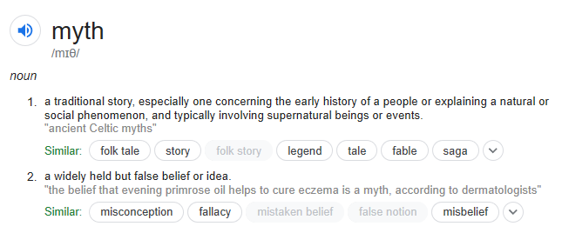
So, myths are not necessarily true stories, but they are stories which we are supposed to learn from. We see characters in the myths acting in lots of naughty or immoral ways and we are supposed to learn from their mistakes.
Task 1 - Introduction:
Please read the following text (‘Ancient Greek Mythology) and highlight or, if you don’t have a highlighter, underline any information which you find interesting.
ANCIENT GREEK MYTHOLOGY
Ancient Greece is well known for its stories of gods, goddesses, and heroes. The word myth comes from the ancient Greek word mythos, which means “a spoken or written story.” Basically, a myth is a story with a purpose. Myths attempt to give explanations for events in the natural world among humans and between deities. Myths can teach societal standards, rules, and expectations in a way that interests the listener. Myths often have spiritual or religious meaning. Every culture, including our own, has its own myths.
A Classical Greek Myth:
- Explains a natural phenomenon or the creation of something
- Depicts a struggle between good and evil
- Shows a relationship between mortals and the supernatural
- Contains magical characters, gods, goddesses, nymphs, giants, etc.
- Sometimes depicts a hero’s quest to accomplish a great feat
- Makes reference to geological places and cultural aspects of ancient Greece

Many people wonder where myths come from. About 2,000 years ago an ancient Greek scholar suggested that all myths are based on historical facts that, over time, have been exaggerated into impossible events. Most modern scholars believe myths serve as metaphors or symbols for teaching the beliefs of a culture. They believe the events are not based in truth but serve as an exciting way to get people to listen and learn from the story. Learning about myths is important when studying history because they teach a lot about a society’s values, life experiences, environment, and beliefs and allow people to compare them to their own. Myths, historical evidence, and archaeological finds offer insight into a society’s past.
Greek mythology begins with Gaia, the earth goddess who formed the world from nothingness. She birthed and later married Uranous, the sky-god. They had a child named Cronus, who left his parents and started a group of fierce gods called the Titans. Nervous about being overthrown by one of his children, Cronus swallowed all but one of them—a child named Zeus. Zeus killed his father, opened his father’s belly and freed his brothers and sisters. Zeus banished the Titans to the Underworld. He went to live on Mount Olympus. The gods and goddesses who lived with Zeus on Mt. Olympus were known as civilized deities, helping to bring order to Greece.
Besides the main Olympian gods and goddesses, Greeks honoured hundreds of other gods and goddesses. Some were local deities, known only to the residents of particular city-states, while others were known throughout Greece.
In addition to the gods and goddesses and their mythical helpers, Greek mythology is filled with the stories of heroes and heroines. A Greek hero or heroine was an ordinary person with extraordinary powers. Sometimes these powers were given by the gods and goddesses; other times their origins were unexplained. The heroes and heroines performed extraordinary feats, generally for the good of the Greek people. A Greek hero is Odysseus, who defeated Troy.
Task 2 - Research
Let’s learn about some of the Gods and Goddesses—specifically the gods of Mount Olympus, also known as the Olympians.
Use the links below to learn more about some of the Olympian gods and goddesses.
Step 2: Complete the Gods and Goddesses table below.

http://www.mythweb.com/gods/index.html
http://www.mythologyteacher.com/Gallery-of-the-Gods.php
http://greece.mrdonn.org/greekgods/index.html

God/Goddess | Responsibility  or Role? | Roman Name?  (if they have one) | Interesting fact(s)
Hermes | Messenger | Roman Name: Mercury | - Son of Zeus, 3,000 years old  - Wears winged sandals/helmet  - Appears in the most myths
Apollo
Ares
Artemis
Athena
Demeter
Aphrodite
Zeus
Hades
Poseidon
Hephaestus
Persephone
Hera

Task 3 - Reading:
Read the following mythological tale about Eros and Pysche. There’s a good video you can watch here: https://www.youtube.com/watch?v=hjDSpuuTddc
Eros and Pysche
Once upon a time, a long time ago, there lived three princesses. Psyche, the youngest, was very kind. She was also very beautiful. She was so beautiful, in fact, that the powerful goddess of love, Aphrodite, became jealous of Psyche.
In fear of what the great goddess might do to them if they paid attention to Psyche, all the young men in the kingdom avoided Psyche whenever possible, and none offered to marry her. Her two sisters married finally. But Psyche stayed at home with her father.
Psyche could not remain at home forever. In those days, girls had to marry someone. Her father consulted Apollo's oracle at Delphi for guidance. You know oracles! Who knows what the oracle actually said? What the king heard was that his beloved daughter should prepare for her death. Sadly, the king took Psyche to the edge of a cliff and left her there.
In despair, Psyche might have leaped to her death. Before she could, she felt herself lifted into the air. Zephyrus, the gentle west wind, had taken pity on the girl, and gently carried her to a faraway palace, to the home of his good friend, Eros, the lonely god of Love.
Eros was a handsome young man, but he had a pair of very big wings. He did not wish to scare Psyche. He made himself invisible and warned Psyche if she valued his love, not to try to catch a glimpse of him.
Psyche was treated with great gentleness and good company and much laughter and soon fell in love with her invisible host. For some time, they were blissfully happy. But Psyche longed to see her family. Eros finally agreed to allow her to invite her two sisters to his palace.
Filled with envy at the sight of the palace and the riches it contained, her two sisters maliciously convinced Psyche that she was being fooled, that her husband was a fearsome monster, and that she had to escape!
"But he's so kind, so gentle," she argued. "He cannot be a monster. I would know!"
"He's fooling you, Psyche. Trust us." They returned home, dissatisfied with their own lives, and jealous of Psyche's.
Psyche cried and cried, but one night, she took a lamp in one hand and a dagger in the other, and crept into her host's bedroom. Instead of the monster she expected to find, she saw Eros, a handsome young man, with two white wings. She was not frightened at all.
A drop of oil from the lamp she held fell on the sleeping god. He woke instantly. He saw his Psyche, leaning over him with a dagger in her hand. With great sorrow, he spread his wings and flew away.
Psyche crumbled to the floor. How foolish she had been to listen to her sisters. She ran outside, to the river. She threw herself into the water. She expected to drown. But Pan, the god of shepherds, pulled her safely from the water.
"Aphrodite is the goddess of love. Ask for her help," Pan advised her.
Psyche prayed to Aphrodite for help. Aphrodite was still jealous. She pretended to help her, because she was, after all, the goddess of love, but gave Psyche tasks to prove her love for Eros that no mortal could possibly accomplish. Yet, Psyche accomplished task after task. Although she did not know it, Psyche was helped by invisible beings, sent by Eros, who loved her still, and watched over her.
At last, Aphrodite told Psyche her final task was to retrieve a box from the underworld, a very special box filled with magical beauty supplies. With these, she could make herself so beautiful that Eros would fall hopelessly in love with her.
You might think Psyche would be excited - her last task! - but Psyche knew she had to die to enter the land of shades. It was hopeless.
Suddenly, she heard a voice speaking softly in her ear. It warned her of dangers ahead and what she had to do to retrieve the box without dying.
The voice was very clear. Here is what she had to do:
1. Have a coin ready for the toll to the underworld
2. Bring three pieces of sweetbread to give to Cerberus, the three-headed dog
3. DO NOT EAT ANYTHING, not even a seed
4. Once you find it, bring the box to Aphrodite without looking inside.
Psyche did everything she was told. She arrived back in the land of light safely. Waiting for Aphrodite to show up, she became nervous. What if it was the wrong box? Psyche opened the box just a crack to peek inside. A foul-smelling cloud poured out. Psyche dropped to the ground as if dead.
To save her life, Eros returned to his visible form, and prodded her with the point of a golden arrow. She awoke immediately.
"Psyche, what am I going to do with you? Will you never learn?"
"I have learned," Psyche said softly. "I've learned that I love you."
Eros gathered her into his arms and flew them back to his palace.
It took a while, but Eros finally convinced his mother, Aphrodite, to accept Psyche as his wife. With Aphrodite's help, he convinced the great Zeus to admit Psyche to the ranks of the immortal gods.
In celebration, Psyche and Eros threw a party at the palace. Apollo played his lyre. Dionysus brought the wine. And all the gods rejoiced. As for Eros and Psyche, they lived happily ever after.

Task 4 - Retrieval:
Eros is usually referred to as Cupid in Roman mythology.
Google him, and, using your own research and the story above, make a poster about Cupid. A successful poster will have a picture in the middle of Eros/Cupid and will be labelled with his features/characteristics.
Task 5 – Creative Writing:
Having powers like Eros’ would have been extraordinary fun. Imagine the fun he could have had with mere mortals! Pretending you are Eros, write a diary entry for a day when you used your magical powers to get up to mischief. Your new English teacher will have a laugh reading these!
Task 6 – Etymology
The word ‘psyche’:
As mentioned earlier, many words we use today come from Greek mythology. Think about the name Psyche from the story we just read. Psyche was responsible for making the God Aphrodite jealous and her beauty was too powerful for Eros to resist. If you Google a word, you can look at its etymology (where it comes from). The word ‘psyche’ is still used in modern English and means the following:
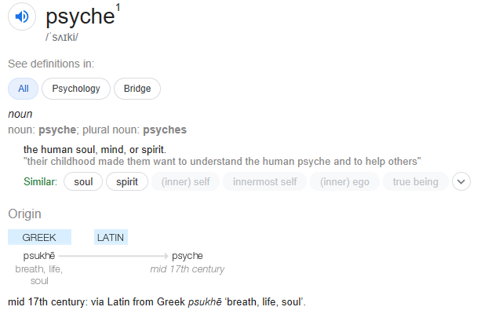
Thinking about the story we just read, can you think of why the word ‘psyche’ means these things today? Because of the Greek stories about Pysche, she became the Greek God for the soul. Today, psychologists study human behaviour and the way that people’s souls affect their actions.
Etymology
When we study a word’s history, it is called its ‘etymology’. Most words in our language started thousands of years ago and formed parts of different languages. The word ‘memory’ is an interesting example. The root of the word is ‘mem’, and the Greek God of memory was called Mnemosyne. Can you see the root ‘mem’ in Mnemosyne? We only use the word ‘memory’ today because we stole the root of the word from Ancient Greece! Mind-blowing, right?
Here are some other words we have stolen from Ancient Greece. Your job is to work out the history of the word. Use Google to help you!
Modern Word | Link to Ancient Greek Mythology | Modern Definition
Zephyr | The Greek God of the west wind who appears in many stories including the story of Eros and Psyche. | A calm and gentle breeze.
Atlas
Music
Nectar
Morphine
Phobia

Task 7 – Easter Egg
On the front cover of this booklet there is a picture of a 3-headed creature. Can you find out information about it on the internet?
Name:

Appearance:

Characteristics:

Stories in which it appears:

Task 8 – Becoming an ‘Expert’.
One of the first things you will do at Prospect School will be to share information you have found out about one of the Gods from Greek Mythology.
Your task is to make a colourful, annotated (labelled) poster of your favourite Greek God. The poster needs to contain at least 10 facts about the God you have chosen. There will be prizes for the best posters when we start in September and we intend to display these in our classrooms.
We can’t wait to meet you and we look forward to seeing your posters and all of the work you have done in preparing yourselves for the Greek Mythology unit at the start of Year 7!

Further Reading/Research:
Now you’ve been introduced to the topic of Greek Mythology, the very best of you will start school with even more knowledge about Greek Mythology. Here are some weblinks to help you:
https://www.youtube.com/watch?v=JbriKmhSggE&list=OLAK5uy_lCmib6Y_s0lnkX26R17VmIc-vdXEPqR3o
https://greece.mrdonn.org/myths.html
https://www.youtube.com/user/GeethanjaliVideos/videos
https://www.amazon.co.uk/Mythos-Greek-Retold-Stephen-Fry/dp/1405934328
https://www.amazon.co.uk/Mythos/dp/B071V69C7T/ref=tmm_aud_swatch_0?_encoding=UTF8&qid=&sr=

